ICT, E-commerce, Statup industry of Bangladesh :

As the ramifications of the COVID-19 crisis continue to be felt across the world, entire industries are struggling under the weight of demand downturn, labor shortages and inability to maintain their supply chain processes.  
  
However, demand downturn has not been the issue of primary concern for all industries. One such industry would be**E-Commerce, which has seen an unprecedented rise in orders for certain businesses and growth of overall consumer base owing to the lock-down in place**.  
  
E-Commerce can be defined as buying and selling of commodities or services through an electronic medium. A distinction is sometimes made between e-commerce which is done through business websites or mobile applications, and f-commerce, which uses Facebook as the platform to facilitate sales.

Bangladesh startup ecosystem is coming of age riding on key drivers:

Strong Economy Vitals for Startups: Tech adaptable young population 62%+ under 35 years, 164 million people (8th largest in the world) with high density (1200 people/Sq Km). Middle class growing at 10% per annum to reach 34 million by 2025, 98% mobile phone connection, 62% internet penetration, 102 million+ people on the internet with 94 million mobile internet penetration. The pandemic has also accelerated the use of ICT technology, including digital commerce, education, healthcare, agriculture.

Demographic Bulge with the Right Skill-sets: The country generates 5,000+ IT graduates each year is creating a strong group of entrepreneurial waves focused on solving critical problems, including those during the pandemic. The country’s median age of 27.9 years means more young people are willing to take risks and explore innovations in the economy. With limited opportunities from STEM graduates (due to the absence of large scale industrialization except for RMG/Textile, which is still more labor-intensive than automation) – they are looking into forming ICT enabled companies and Startups. NRBs (Non-Resident Bangladeshis) are also returning, bringing in both investment capital and knowledge remittance.

Bangladesh Startup Ecosystem at an Inflection Point: The Bangladesh Entrepreneurship Ecosystem is at an inflection point with an excess of U$ 200 million in international investments from big-name corporate investors and venture capitals, investing in industries like FinTech, Logistics, and Mobility over the last four years. The emergence of active Angel Investment Networks, Impact Investing, host of local and international operating accelerators/ incubators propelled 1,000+ active Startups, generating 1.5 million+ employment – embracing products and services of Startups as part of the country’s everyday life. Additionally, B-SEC (Bangladesh Securities and Exchange Commission) has also approved small-cap stock exchange guidelines, which is a big step towards providing investors with Startup exits.

Government Support: The Government of Bangladesh deployed the National ICT Policy in 2009 to become Digital Bangladesh by 2021. Government policies and projects from the ICT Ministry, such as IDEA Project and Startup Bangladesh Limited with 100 crore BDT  (U$ 11.5 Million) funds, are taken to improve the local startup ecosystem. Additionally, GoB is setting up 28+ Hi-Tech Parks, including infrastructure support like data centers, to support technology companies.

COVID-19 Impact: Since March 2020, the country and all its businesses and startups have been affected drastically by the COVID-19 disruption. 24% of companies reported to have stopped operations, with 56% of startups seen at least a 50% drop on revenue generation. 60% of Startups have runway less than three months threatening 1.5 million employment and an annual loss of over U$ 53 Million in 2020. The disruption, however, is also propelling accelerated adoption of digital services with Digital Financial Services, Logistics, and Grocery on-demand, EdTech, HealthTech seeing steep growth.

The Market at a Glance

The E-Commerce industry in Bangladesh began to flourish circa 2013 with the Bangladesh Bank lifting its previously established restriction on international purchases via consumer credit cards.  
  
In 2018,  **Alibaba, the China-based global e-commerce giant, acquired Daraz Group, one of the leading e-commerce companies in Bangladesh,** launched initially by Rocket Internet. It was a strategic play to open up South Asian Markets and cast an important limelight on the sector. [1]  
  
While this was a huge boost to the growth of e-commerce, **other factors also played a defining role, such as the gradually improving access to the internet and rising smartphone usage across households.**

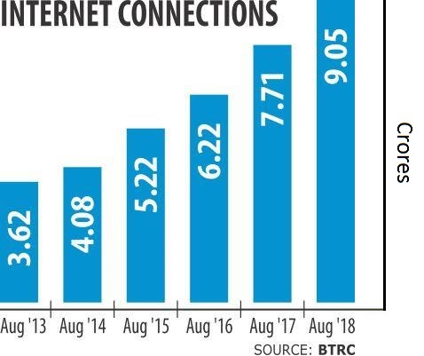

**FIGURE** : Internet Users in Bangladesh

Globally,**the biggest countries in terms of e-commerce sales were The United States of America (USD 8,640bn), Japan (USD 3,280bn), China (USD 2,304bn), Korea (Rep) (USD 1,364bn), and United Kingdom (USD 918bn) in 2018**. [2]

The market valuation of the E-commerce industry is contested by different sources such as Statista and e-Commerce Association of Bangladesh (e-CAB), however**the latter estimates it to be around Tk 8,000 crore with an annual growth rate of approximately 50 percent. [3] It also estimates there are currently around 500 websites and 2000 Facebook-based companies present in the industry**.

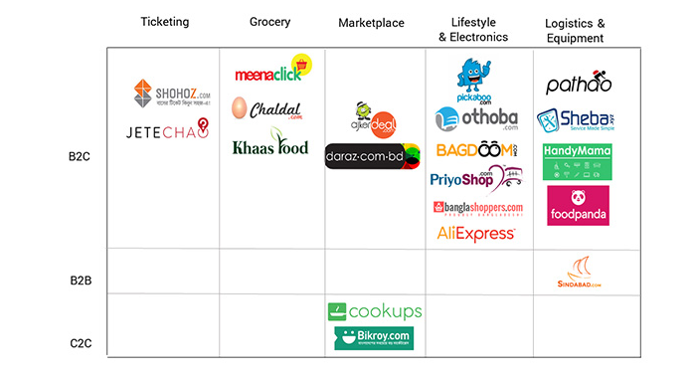

Fig: Notable Businesses in the E-Commerce Industry

## **Bangladesh: The Untapped Economy in Chindia**

Bangladesh, the **39thlargest economy**and one of the fastest-growing countries, showed an impressive annual GDP growth rate of **~6.5%** over the last decade. The country’s annual GDP growth rate officially surpassed that of India’s in 2016 and has been higher than that of its neighbor since then.

GDP per capita has been growing at rates over **5%** since 2015 peaking at **U$ 1,855**(as of 2019), which is almost equal to China in 2005. The final consumption expenditure, which accounts for private consumption and general government consumption, has been growing positively for the last 10 years.

The economy is on track in graduating from the **LDC status in 2024**and has made impressive strides in human development. PwC, a global consultancy, also predicts Bangladesh to become the **28th largest economy**in the world by 2030.

It dominates the **global RMG market in 3rd position**, right after China and Vietnam, earning **U$ 34Bn**(**83%**of total export earnings) as of 2019. Its ICT sector is booming, exporting **U$ 800Mn**worth of service across the globe.

The country has a population of 164 Mn and has reached 37% urbanization. Connectivity has reached its peak, with **98%**mobile phone connection (**161Mn**) and **62%** internet penetration (**102Mn**) and **57%**mobile internet penetration (**94Mn**).

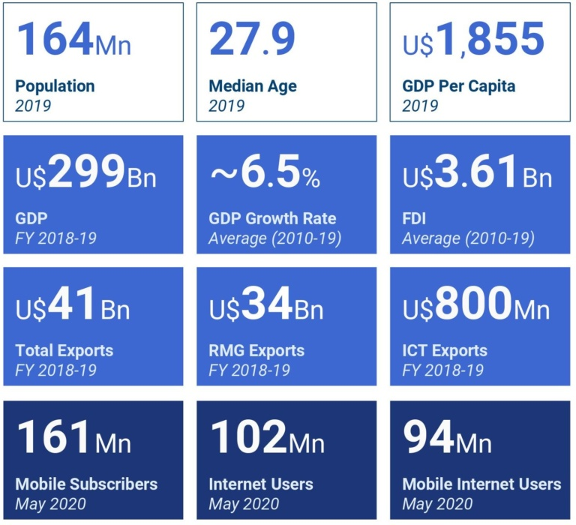

Fig: Economic indicators of the past decade suggest growth for the country  
Source: BTRC, World Bank, UNCTAD, Ministry Briefings, BBS, EPB & Bangladesh Bank

Bangladesh recorded an impressive annual GDP growth rate of **8.1%**in 2019; the highest in the country’s history and in South Asia for 2019. The strong performance is attributable to a number of factors that have contributed to inclusive economic growth

According to The Bangladesh Bureau of Statistics (BBS), the country has a young population with a median age of ~**28 years** and**62%** of the population below the age of 35.

The country also benefits from ‘density dividend’, as **164 Million**population is nestled in a country with a land size similar to that of Michigan, USA.

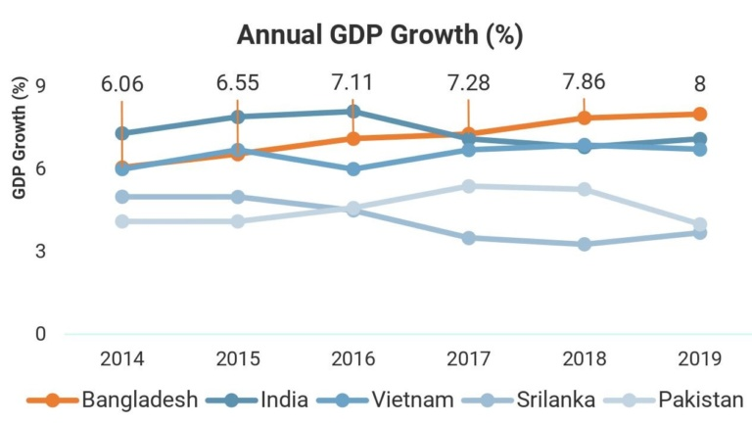

**Fig:** Annual GDP Growth of Bangladesh  
Source: BCG, World Bank & LightCastle Analysis

While the crisis has sparked a skyrocket of demand for certain parts of Bangladesh e-commerce, the industry as a whole is suffering along with most other industries. When the crisis eventually subsides or is deemed to be in a controlled state, industries will reopen fully. This will mean that while some consumers will revert back to traditional systems of shopping, the growth to the e-commerce sector will normalize and sustain. After all, the core selling point of e-commerce will always continue to be customer convenience.

The stimulus package of Bangladesh is already working to mitigate damages and the way forward for businesses will depend on capital availability and labor readiness.**However, with such major strides taken in terms of increase in volume of online shoppers, a post COVID-19 boom for the sector seems to be on the cards.**

## References

* 1. [Alibaba buys out Daraz from Rocket Internet](https://www.dhakatribune.com/business/2018/05/08/alibaba-buys-daraz-rocket-internet/) – The Dhaka Tribune
* 2. [Global E-Commerce sales hit $25.6 trillion in 2018: UNCTAD](https://unb.com.bd/category/Bangladesh/global-e-commerce-sales-hit-256-trillion-in-2018-unctad/50673) – UNB.com
* 3. [Bangladeshis adopting e-commerce faster than ever amid pandemic](https://www.thedailystar.net/business/news/bangladeshis-adopting-e-commerce-faster-ever-amid-pandemic-1890688) – The Daily Star
* 4. [About e-CAB e-CAB](http://e-cab.net/about-us/) – eCAB
* 5. [Online shopping of essentials soars as corona cases spike](https://unb.com.bd/category/Special/online-shopping-of-essentials-soars-as-corona-cases-spike/49446) – UNB.com
* 6. [E-commerce suffers on supply crunch](https://thefinancialexpress.com.bd/trade/e-commerce-suffers-on-supply-crunch-1586572069) – The Financial Express
* 7. [What do consumers expect from brands?](https://consulting.kantar.com/wp-content/uploads/2020/03/COVID-19-Asia-Infographic_FINAL.pdf) – Kantar Group
* 8. [Online grocers fail to seize the day during biggest opening yet](https://www.thedailystar.net/business/news/online-grocers-fail-seize-the-day-during-biggest-opening-yet-1897495) – The Daily Star
* 9. [What does COVID-19 mean for angel investing in Bangladesh](https://hifipublic.com/en/2020/04/22/what-does-covid-19-mean-for-angel-investing-in-bangladesh/) -The HiFi Public